16th International Conference on Microwave and High Frequency Heating
AMPERE 2017, Delft, The Netherlands, September 18-21, 2017

PAPER TITLE——CENTERED, CAPITALS AND BOLD

A. Author¹, B. Author², C. Author¹,

¹Institute of affiliation, Address, City, Country
²Institute of affiliation, Address, City, Country
e-mail@address.com

Keywords: microwave, radio-frequency heating, power applications

Introduction
Body text is 12pt Times New Roman or similar, justified, single spaced. Page size is A4, left and right margins are 30 mm, top and bottom margins are 25 mm.

The paper length may vary between 4 to 8 pages.

Table 1. Table caption.
Column | Column | Column
Table | Table | Table
Table | Table | Table

Heading (Times New Roman 12pt bold)
Pellentesque maximus a nunc et scelerisque. Pellentesque habitant morbi tristique senectus et netus et malesuada fames ac turpis egestas. Pellentesque habitant morbi tristique senectus et netus et malesuada fames ac turpis egestas. Aenean ac volutpat nibh. Aenean non dui sodales, aliquet urna sed, lacinia nisi.

Cum sociis natoque penatibus et magnis dis parturient montes, nascetur ridiculus mus. Proin dignissim arcu nunc, id blandit mauris pellentesque at. Aenean consequat justo libero, eu dignissim nisl convallis rutrum. Duis scelerisque urna id ornare venenatis.

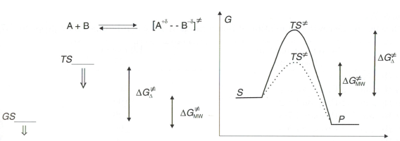
Fig. 1. Figure caption; centered when just one line, justified when more.

References
- Author, A., B. Author, Abbr. Journal Name, 2017, 12, 345–678.

